City of Kinmundy
Permit No.________________
Dated Issued:______________
Fee Paid:_________________
Check #:_________ Cash:____

P.O. Box 58
Kinmundy, IL 62854

APPLICATION FOR BOAT PERMIT

Name:________________________________________________________________________

Residence Address:______________________________________________________________

City, _______________________State_________ Zip__________________
Boat Information:
Length:____________________________________________
Passenger Capacity:__________________________________
Type of Boat:_______________________________________(sail, motor, etc.)
Horsepower:________________________________________

Liability Insurance Carrier:________________________________________________________
(proof of insurance required)

I hereby certify the information provided herein is true and correct. I agree to abide by the rules and regulations set forth herein as well as obey the applicable laws and/or ordinances of the State of Illinois and those of the City of Kinmundy in the operation of my boat on the lake.

____________________________________
Signature of Applicant

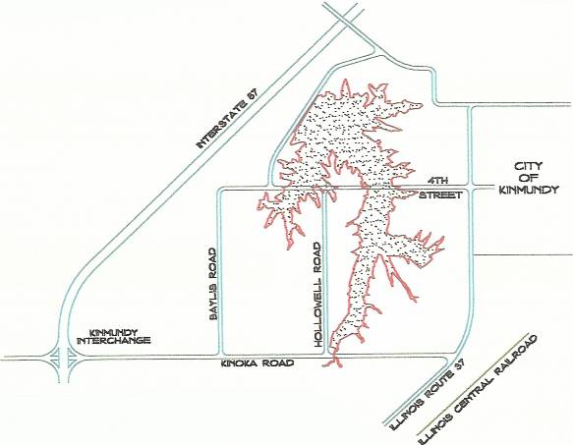
Rules and Regulations

- Boat stickers will be clearly displayed on a trailer or other vehicle remaining on land.
- No jet skies will be allowed on the lake.
- No wake allowed on the lake.
- No swimming, scuba diving or skiing allowed on the lake.
- No alcoholic beverages allowed at any time on the lake.
- Fishing limitations:
  - 15” minimum length limit
  - 6 fish daily creel limit for largemouth bass
  - 6 fish daily creel limit for channel catfish
Fee Structure: Kinmundy Residents Non Residents
January – March $20.00 $40.00
April – June $15.00 $30.00
July – September $10.00 $20.00
October – December $5.00 $10.00

